Neighbourhood House Supervision Framework
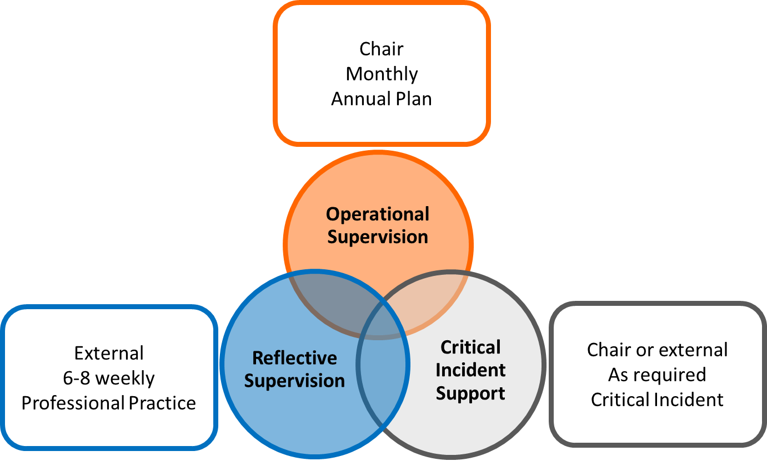
WHAT IS SUPERVISION?
Supervision, in the Neighbourhood House sector, is the formal engagement between the Coordinator and the Committee of Management (chair or other representative) with the purpose of addressing complex issues, reviewing performance against goals and plans, and maintaining a transparent and supportive relationship at a leadership level.
WHY THIS FRAMEWORK?
It is specifically tailored to this sector
The Neighbourhood House sector has a unique governance structure that is at times inconsistent and limiting in accountability. This Framework provides a simple yet consistent structure under which supervision can be both provided and received which will in turn
a) increase visibility and accountability of Coordinator and Committee of Management performance and
b) provide a platform to discuss risks and challenges to address them efficiently and as a result minimise impact and
c) increase achievement of goals as determined by the strategic planning process.
It assists the sector to meet funding requirements
The Department of Health and Human Services (DHHS) through the Neighbourhood House Coordination Program provides funding to neighbourhood houses allocated on the basis of hours of coordination (as identified in each service agreement). As stated in the Neighbourhood House Coordination Program Funding Guidelines 2016-2019 the funding assists with employing a coordinator and the related costs to:
- provide a balanced mix of community development planning and activities that achieve each of the program aims
- promote participation in the neighbourhood house program and activities by diverse community groups and individuals
- be open for at least as many hours as the Neighbourhood House Coordination Program provides coordination funding
- provide at least twice as many activity hours as the number of coordination hours funded by the NHCP. Activities may be provided concurrently.
It is expected that the planning, development and delivery of these program requirements will be based on a documented, resourced and supported annual plan. It is also expected that the funding is utilised to resource the necessary supports for the Coordinator in their role and the role of the Committee of Management.
Whilst this Framework provides a customised approach to the delivery of supervision, supervision itself is not a new or additional requirement, but an existing and necessary development/support tool for both coordinator and committee of management and is encouraged as a best practice method/model for neighbourhood houses under the neighbourhood house program.
COMPONENTS OF SUPERVISION
OPERATIONAL SUPERVISION
Overview: Operational supervision provides the supervisor and the supervisee with an allocated opportunity to engage in discussion relating to the coordinator role and the ongoing operational requirements. Crucial to this component of supervision is the review of compliance against the Strategic Plan and Annual Plan and/or the Coordinator’s Work Plan and the identification and mitigation of risks on a regular basis.
Provided by: Committee Chair or Committee delegate
Determined by: Coordinator’s Annual Work Plan and Strategic Plan
Primary Focus:
- Administrative matters relating to staff and volunteers, the coordinator’s employment, leave and performance against vision, mission, values and sector principles.
- Professional development needs and opportunities
- Achievement of goals and associated activities as outlined in Annual Plan
- Review of budget
- Identification and mitigation of risks to children, young people, participants, staff, operations, organisational reputation or the broader community.
Frequency:
Monthly (Performance Reviews should be conducted separately, on an annual basis.)
Tools:
- Operational Supervision Agreement
- Supervision Record template
- Annual Plan
- Committee Update template
Additional:
Summary of supervision including issues, risks and a table tracking Annual Plan activities to be tabled at next Committee meeting using the Committee Update template.
REFLECTIVE SUPERVISION
Overview: Reflective Supervision provides an opportunity for the supervisee to reflect on practice, workplace dynamics, personal performance, growth and development in a safe and non - judgemental environment. Often reflective supervision is undertaken with an external professional and the agenda is determined by agreed goals and the Coordinator’s priorities.

Provided by: Committee Chair or Committee delegate or external provider
Determined by: priorities as identified by Coordinator.
Primary Focus:
- Opportunity to critically reflect on practice achievements and challenges including managing internal dynamics, operational challenges relating to governance and leadership.
- Opportunity to seek support and guidance to manage interpersonal conflicts that may arise.
- Opportunity to seek support and guidance in relation to managing conflicting work and personal demands.

Frequency:
Once every 8 weeks

Tools:
- Reflective Supervision Agreement (external provider)
- Supervision Record template (external provider)

CRITICAL INCIDENT SUPPORT
Provided by: Committee Chair or Committee delegate or external provider
Determined by: the relevant critical incident
Primary Focus:
- Current, presenting risks/challenges
- Coordinators current presenting support needs
- Plan going forward in terms of reporting/notifications, future risk mitigations, coordinator support needs.
Frequency:
As specifically requested in relation to an incident.

WHAT IS EXPECTED OF ME?
Supervisor expectations:
- Present to supervision focused and prepared
- Seek contributions to agenda
- Provide a safe and confidential space
- Manage time effectively throughout the session
- Take required notes and record agreed actions
- Conduct supervision in a respectful and non- judgemental manner
- Allow supervisee freedom to speak honestly and openly
- Provide constructive and useful feedback
- Ensure risks are discussed and mitigated
- Ensure roles of supervisor and supervisee are clear
- Follow up on agreed actions in a timely manner
Supervisee expectations:
- Present to supervision focused and prepared
- Contribute to agenda
- Bring relevant documents for review
- Engage in supervision in a respectful and non- judgemental manner
- Actively contribute to discussions openly and honestly
- Give and receive feedback respectfully and constructively
- Accept responsibility for own actions and outcomes
- Seek guidance and advice
- Follow up on agreed actions in a timely manner

WHAT TOOLS DO I NEED TO FULFIL MY ROLE?
Supervision agreement: This document should be signed by both parties at the beginning of the supervision process and resigned if either the supervisor or the supervisee changes at any time.
Supervision template: This document should be completed by the supervisor during each supervision session with a copy made available to the supervisee at their request and kept in a secure location. This document should capture comments and notes relating to the discussion and should always include specific goals and actions to be completed in the Actions Table provided with signatures from both parties to confirm agreement of the content.
Committee Update template: This document will summarise relevant information and key themes form Operational Supervision to be tabled by the Chair (or delegate) at the next Committee meeting.

